PLAYING FIELD DEVELOPMENT - PUBLIC CONSULTATION.

Introduction

Stithians Parish Council in its role as Trustee of the Stithians Playing Field are continually looking for ways to improve access and facilities in the playing field available to our community. There are a number of ideas, well beyond the financial means available, so we are conducting a public consultation by way of this survey so you can have your say and help us prioritise the projects you would like to see progressed. Please consider the following 5 projects and answer/comment as appropriate.
Forms should be completed and returned to Yew Tree Cottage, New Road, Stithians TR3 7BL on or before Tuesday 2nd November 2021.

Project 1

To create an “all weather figure of 8 footpath around both playing fields. The path would be wide enough for families/friends to walk 2 or 3 abreast, with a surface that would be suitable for prams, child bikes etc. The path would be predominantly level and be easy to access for people with disabilities. Preliminary costings suggest costs of the order £35-£40,000.
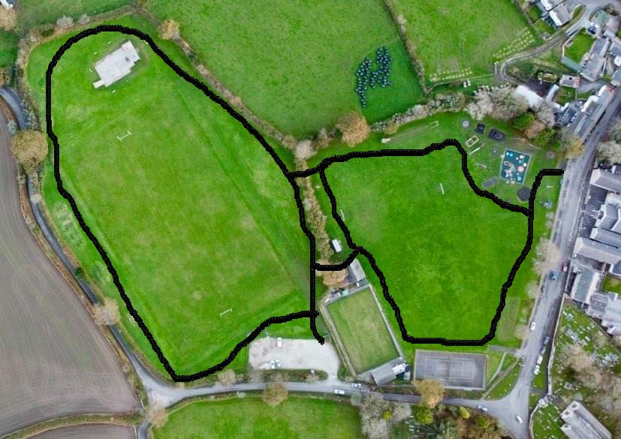

Questions
1a – Do you like this idea? Y/N
1b – Would you or your family use is? Y/N
1c – Do you have any comments on Project 1
………………………………………………………………………………………………………………………………………………………………………………………………………………………………………………………………………………………………………………………………………………………………………………………………………………………………………………………

Project 2

To install a dedicated all weather Multi Use Games Area (MUGA).

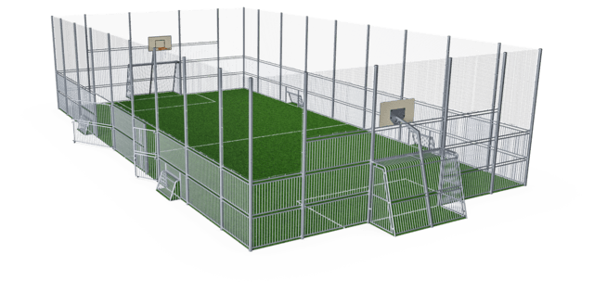
There are multiple configurations for various sports but typically include Basketball, 5 a-side football, toddler football. Other sports that can be included with additional kit is Tennis, Badminton and Volleyball. Courts can either be permanently open for adhoc use or securely locked so that access/use is controlled (as shown). Preliminary costings suggest prices of the order £55-£65,000.

Questions

2a – Do you like this idea? Y/N
2b – Would you or your family use is? Y/N
2c – Would you prefer open adhoc access? Y/N
2d – Are there any other sports you would like included?
2e - Do you have any comments on Project 2?
………………………………………………………………………………………………………………………………………………………………………………………………………………………………………………………………………………………………………………………………………………………………………………………………………………………………………………………

Project 3

Would be a cheaper version of project 2 but instead of building a new MUGA the existing tennis courts could be resurfaced and converted to a MUGA. This project would still cost approximately £35- £40,000. There would need to be compromises with multiple users and it would need to be controlled and booked access to avoid conflict of use.

3a – Do you like this idea? Y/N
3b – Would you or your family use is? Y/N
3c – Would you be happy with booking/controlled access? Y/N
3d – Are there any other sports you would like included?
3e - Do you have any comments on Project 3?
………………………………………………………………………………………………………………………………………………………………………………………………………………………………………………………………………………………………………………………………………………………………………………………………………………………………………………………

Project 4

A selection of Adult Outside Gym equipment. Cost of the order £10-£15,000.

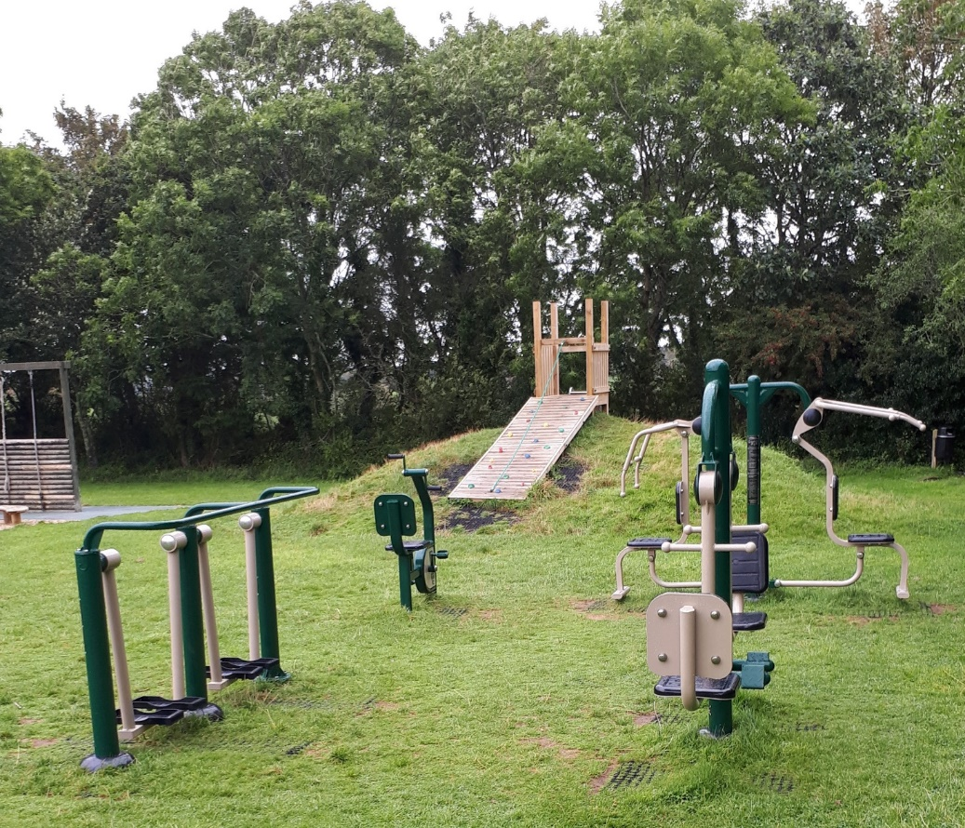

4a – Do you like this idea? Y/N
4b – Would you or your family use is? Y/N
4c – Should this be located close to existing play equipment or more remotely?
4e - Do you have any comments on Project 4?
………………………………………………………………………………………………………………………………………………………………………………………………………………………………………………………………………………………………………………………………………………………………………………………………………………………………………………………

Project 5

Additional landscaping seating, tables and social areas. This could range from more picnic benches to more bespoke seating/social areas. Approximate cost depending on detail scope & numbers £2k - £6,000.
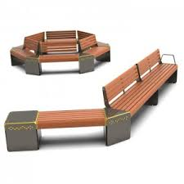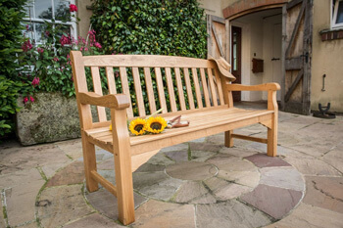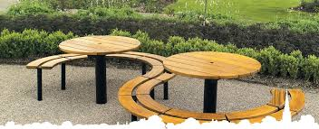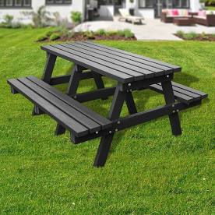
Examples only

5a – Do you like this idea? Y/N
5b – Would you or your family use is? Y/N
5c – Would you prefer simple picnic benches or more bespoke solutions? Simple/Bespoke
5d – Would you like to see more seating near the play area or in other locations? Near/Further/Both
5e - Do you have any comments on Project 5?
………………………………………………………………………………………………………………………………………………………………………………………………………………………………………………………………………………………………………………………………………………………………………………………………………………………………………………………
Question 6

Please rank the projects in order of your preference with 1 being your favourite project

PROJECT | RANK 1=FAVORITE 5=LEAST FAVOURITE
1 - All weather footpath
2 - All weather Multi Use Games Area (MUGA)
3 – Convert Tennis Court to MUGA
4 – Adult Outdoor Gym Equipment
5 – Additional seating/social areas

Question 7

Please provide any comments or other ideas you may have to further improve the playing field for all it’s users.
……………………………………………………………………………………………………………………………………………………………………………………………………………………………………………………………………………………………………………………………………………………………………………………………………………………………………………………………………………………………………………………………………………………………………………………………………………………………………………………………………………………………………………………………………………………………

