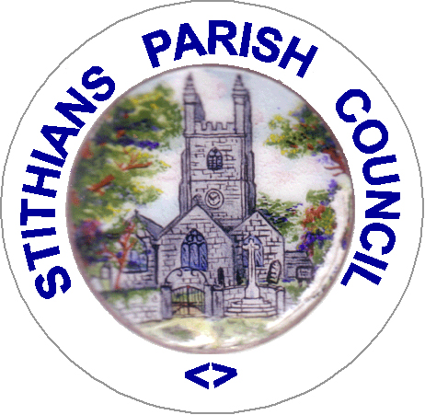

NOTICE OF ANNUAL PARISH MEETING

To be held on

TUESDAY 23rd APRIL at 7 p.m

in the Hendra Room at the ,STITHIANS CENTRE

This is a PUBLIC MEETING everyone is welcome to attend, meet the Parish Council, review what’s happened over the last 12 months and make your views known on what matters to you.

Agenda

Apologies.

Public Presentations - Presentations from local groups and organisations on activities and achievements over the last 12 months.

Presentation of the Star of Stithians Award

Chairman’s Report to include updates on the:.

Longdowns Crossing

Proposed works to highway & footpath around the Spar

Pavilion Replacement

Public Participation – Members of the public are invited to raise any matters of interest or concern.

Date of next meeting –22nd April 2025.

Councillor Miss Helen Downing
Chairman 9th April 2024

